ESO203A Tut 1 13.1.17

Q1: In the circuits of Figure 1 let ‘e’ be sinusoidal at 50 Hz, 100V rms. In the steady state ‘i’ has a value of 10A and is in phase with ‘e’.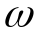L = 10 ohms. Find the value of voltage vector ‘v’. Draw a phasor diagram for the circuit. If R = 20 ohms, what is the power dissipated in R? Is |v| > |e|?

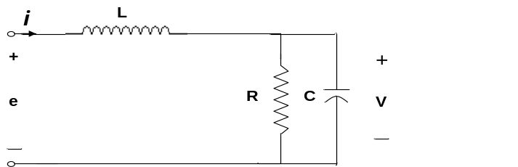

Fig 1
[Answer: 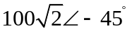, 1kW]

Q2: A three phase balanced star-connected load of 150kW, takes a “leading” current of 100A .The line voltage is 1100V, 50Hz. Find the circuit constants of the load per phase. Draw a phasor diagram of the circuit voltages and currents.
[Answer:Load is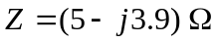per phase. Leading implies capacitor of 816µF in series with 5Ω resistor. A parallel combination of R=8.04Ω and C=308.7µF is an alternate possibility]

Q3: Three non-reactive resistors of 10, 20 and 25are star-connected to the A, B and C phases of a 400V three phase symmetrical system. Determine the current and power in each resistor and the voltage between the star point of the load and the neutral of the supply.
[Answer: 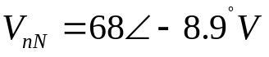 phases a, b, c respectively draw 16.45A, 2.72kW; 13.15A, 3.43kW;11.14A,3.14kW, ]

Q4: A balanced star connected load of 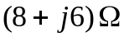 per phase is connected to a three phase 230V supply. Find the line current, real power (W), reactive power (VA) and total VA. Draw phasor diagram of line currents and phase voltages.
[Answer: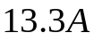, ,P= 4.232kW,Q=3.174kVAr, S=5290VA]

Q5: Repeat the circuit of Q4 assuming the load is connected in delta.

[Answer: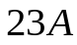, ,P= 12.7kW,Q=9.52kVAr, S=15.87kVA]

